**Mini Project 1**

Product: Coffee Machine

1. **ANALYSIS**

Philips Coffee Maker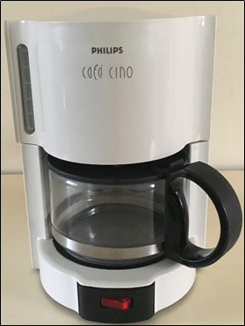

The Philips Coffee Maker mainly consists of the main body, carafe, and the filter basket unitt. Furthermore, the main body holds the detachable filter basket unit, heating element, and the water reservoir. The water reservoir is located at the back of the main body, and can be located by lifting the cover of the main body. Once the water is poured in the water reservoir, water falls through a hole located at the bottom of the water reservoir. That hole is linked to the heating source located at the bottom of the main body or under the heating plate. The heating unit and the holes are connected with two plastic tubes. The water moves up from the heating element back to the water reservoir through an isolated water channel. Now the water channel leads to the filter basket unit, where the coffee is brewed. Underneath the filter basket unit, there is a mechanism consisting of a spring and a stopper. The stopper is only open when the carafe is placed underneath. The carafe consists of a lid, handle, and a metal strip. The lid pushes the stopper mechanism underneath the filter basket unit and the metal strip holds the carafe handle to the carafe. Lastly, the heating element located at the bottom of the main body or underneath the heating plate. The heating element consists of a heating element, U-shape metallic tube, and plastic tubes. The heating element is attached to the U-shape metallic tube; they both produce heat. The U-shape metallic tube is located underneath the heating plate and the carafe serving as a heating source to keep the coffee warm. 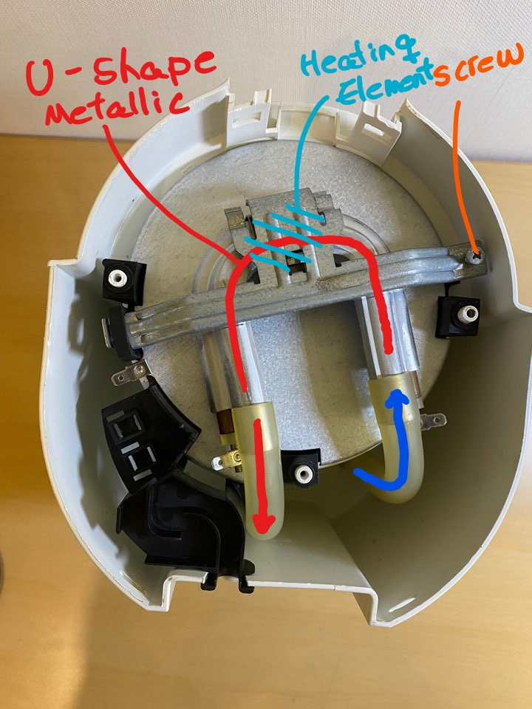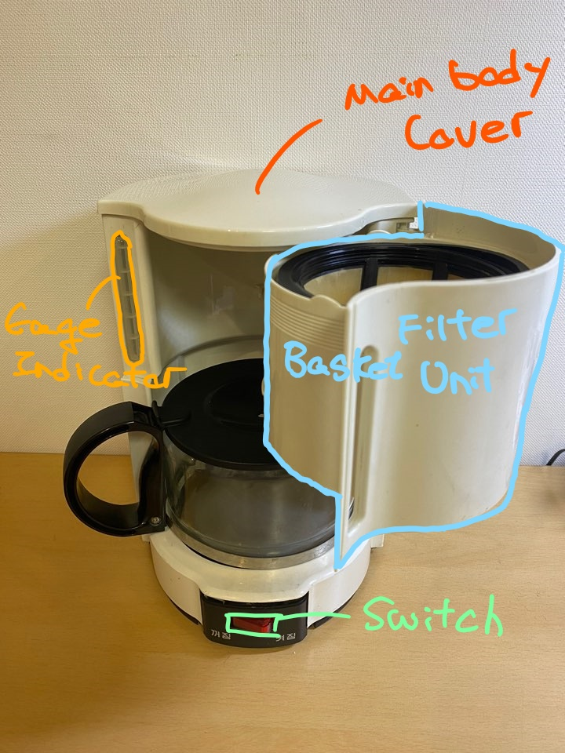

**1.2**

As mentioned above, the Philips Coffee maker consists of mainly three units, main body, filter basket unit, and the carafe.

First, the carafe has five components: carafe glass, lid, handle, metal strip, and a screw. The handle is hooked to the carafe glass at the top part while the metal strip holds the glass and the handle together at the bottom. A screw locks the metal strip and the handle together. Lastly, the lid of the carafe is attached to the handle. 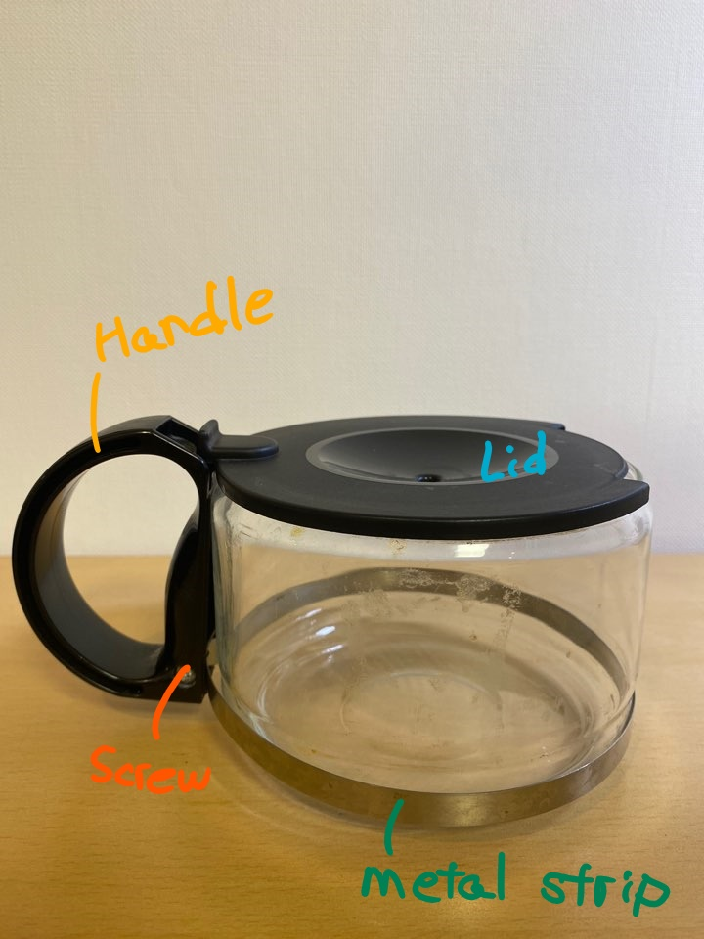

The second simple part is the filter unit. The filter unit has a spring, stopper, filter, and the filter unit. The filter just slides on top of the filter unit. Then the spring and the stopper are attached to the bottom of the filter unit. 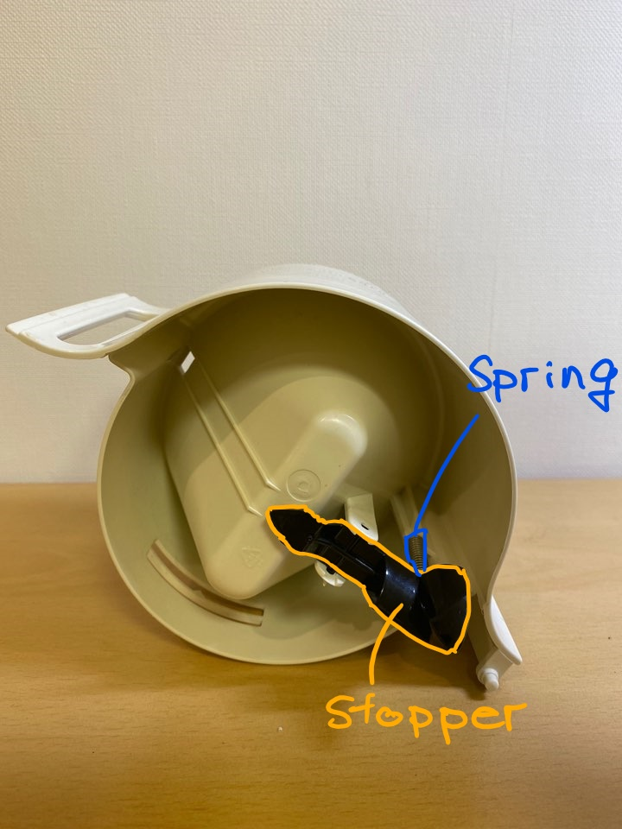

Most importantly, the main body consists of main body, main body cover, water channel, water reservoir, two plastic tubes, heating unit, heating unit clamp, wires, heating plate, heating plate housing, switch, electrical connectors, U-bracket, power supply, and bottom cover. To start from the bottom, heating place housing slides to the main body from the bottom. Then the heating plate is assembled underneath the housing. The source of the heating plate, the heating unit, consists of a U-shape metallic tube and heating element attached to the tube are located underneath the plate providing heat to the already brewed coffee in the carafe. The heating unit is attached to the main body by a heating unit clamp with a screw. One of the plastic tubes connects the U-shape tube to the water chamber while the other connects to the water channel. The water channel slides on top of the main body near the water chamber. Now the power comes from the power supply to the heating element and U-shape metallic tube via U-brackets. The U-brackets are attached to the heat plate housing unit, only visible once the bottom cover is removed. All electronic wires are connected to each part via electrical connectors. Lastly, the bottom cover has a switch that clamps on to the front, and two screws hold the bottom cover to the main body. 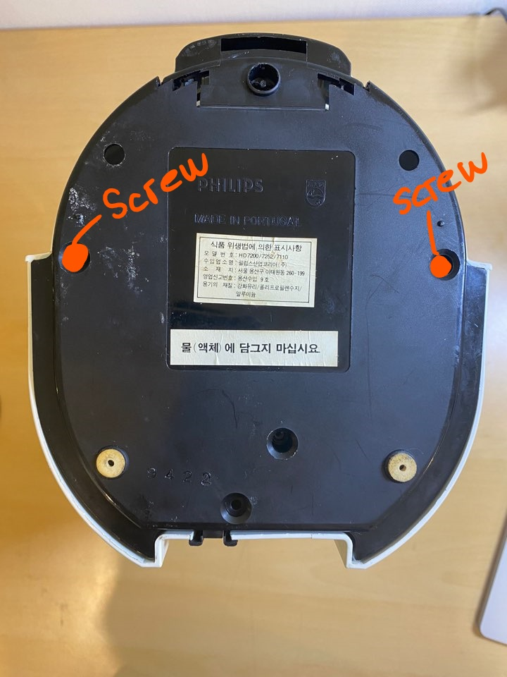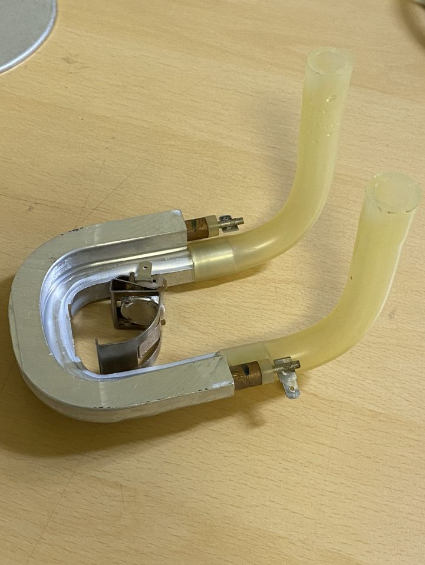



|  |  |  |  |
| --- | --- | --- | --- |
| **1** | **Main body** | **13** | **DEFOND T85 switch** |
| **2** | **Water reservoir** | **14** | **Metal ring** |
| **3** | **carafe** | **15** | **U-tube clamp** |
| **4** | **Water channel** | **16** | **Plastic ring** |
| **5** | **Power supply plug** | **17** | **screws** |
| **6** | **Electrical connectors** | **18** | **Wiring** |
| **7** | **U-brackets** | **19** | **Hot plate** |
| **8** | **Main body lid** | **20** | **Dripstop** |
| **9** | **Metallic U-tube** | **21** | **Carafe handle** |
| **10** | **Heating element** | **22** | **Spring** |
| **11** | **Bent tubes** | **23** | **Stopper** |
| **12** | **Base plate** | **24** | **Filter basket** |

**All the parts of Philips Coffee Maker**

**Below are the photos of the heating unit. Left is with wires and on the right side photo is after the wires are removed.**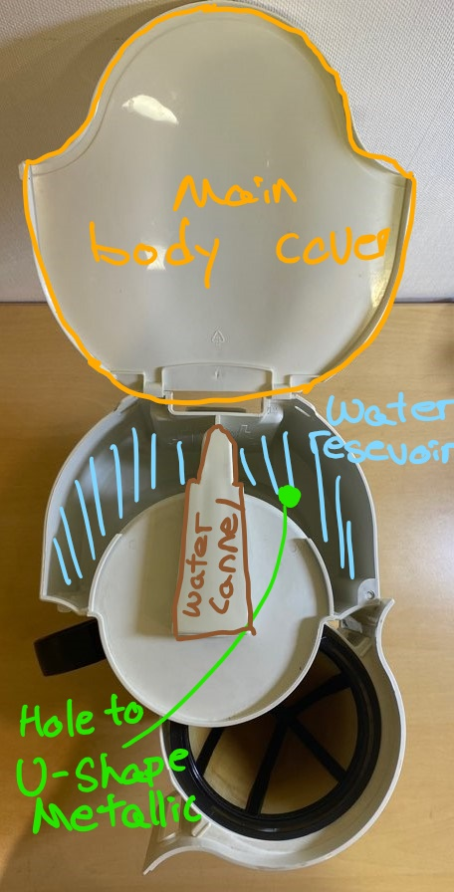

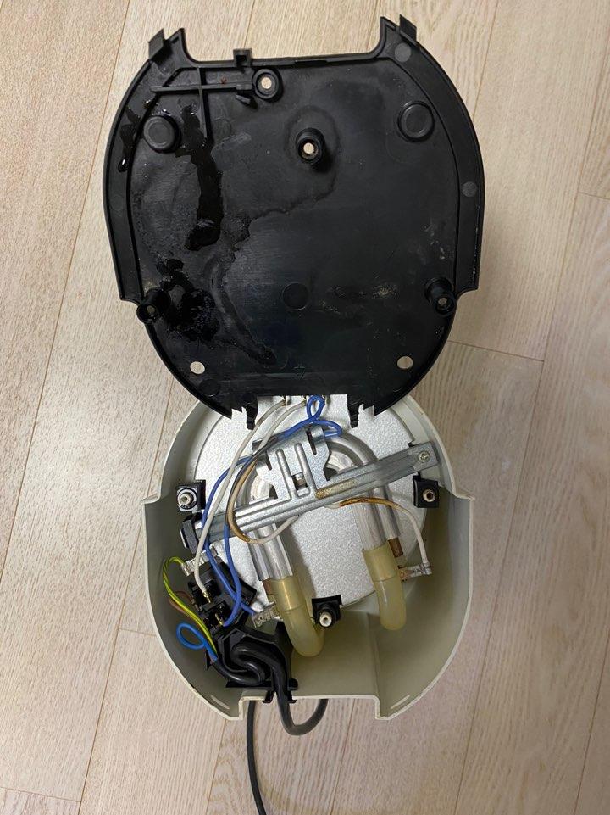

**1.3**

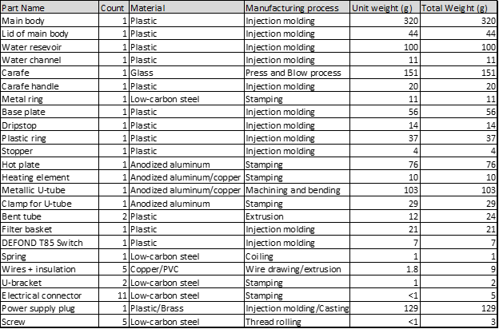

The total number of individual parts for the product is 46, including all individual screws, connectors, and wires. The final count for the components was slightly higher than our initial estimate but was not unexpected. Most of the parts were clearly defined as individual components with the exception of the power supply plug, where there was ambiguity in considering the wire cord separate from the main plug head. A final decision was made to consider both parts as a single sub-assembly.

**1.4**

The following table shows the product-specific parts and standard components of the coffee maker.

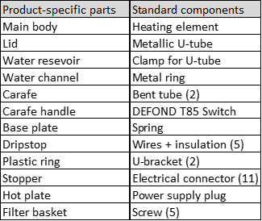

**1.5**

For the three product specific parts, we have chosen the lid, carafe, and hot plate. The lid is made from plastic. It is very lightweight and flexible, with a glossy surface. The carafe is made of glass, which is transparent, brittle, and vulnerable to fracturing from mechanical shock. The hot pate is made from anodized aluminum, it is a good heat conductor, very stiff and dull, and has a brushed finish.

**1.6**

The lid was manufactured using injection molding of plastics. Evidence of injection molding such as visible feed and injector points were present on the component. The curved surfaces as well as material choice also suggests injection molding as the manufacturing process for this part.

The carafe was manufactured via the press and blow process, which is commonly used for making glass containers. This is the preferred method of glass shaping for wide-mouthed jars such as the carafe.

Metal stamping was used to manufacture the hot plate. The part is relatively thin and possesses no curved surfaces which makes it suitable for production via stamping. The geometry of the circumference was obtained through trimming, a method of metal stamping that removes the outer perimeter of the formed part in order to obtain the desired shape.

**1.7**

The sales price for this coffee maker can no longer be found on Philips’ website, but it is estimated to be under $50 as we searched up similar coffee machines on Amazon. A closer estimate would be around $20. We also know that most retail prices can be 3-5 times higher than the production cost, so we assume the manufacturing cost ranges between $5-$10 to manufacture each coffee maker. From analysis of the designers’ DFM techniques on cost, function, and quality of the coffee maker, we consider this estimate to be possible.

From the sales price of the coffee maker it seems that the designer is trying to make a very simple coffee maker that is low-cost and efficient for people who drink coffee often and are either not able to purchase coffee from coffee stores or are unwilling to do so. At this price point, functionality is stripped to the bare minimum: the coffee maker only boils water and runs it through ground coffee and stores it in the carafe. Most of the body of the coffee maker is made of plastic, which are produced through injection molding. We assume the fixed cost for this technique becomes insignificant when the coffee maker is mass produced. Other manufacturing techniques such as stamping and casting seem expensive if only a small amount of parts are made, but with mass-production these costs can also be overlooked.

Overall, it is quite obvious that in order to maintain such a low-cost product for consumers, the designer chose a very simple and cost-efficient way of manufacturing this product. However, the manufacturing cost can be kept low also because of the cheap materials used to produce this coffee maker. This means that the machine would not have a very long product life span, so the quality of the product is actually pretty low. In other words, the designer compromised the quality of the coffee maker for cheaper materials and manufacture, thus making these types of coffee makers so cheap and accessible for more households.

1. Design Challenge

